Asimov Buy Jupiter and Other Stories, Doubleday 1975 Stated First Ed , First print gutter code Q27. Dust jacket as new unclipped price $5.95 in mylar. As new hard cover book with all 206 pages tightly bound and without any marks of any kind. Cover design Michael Flanagan. ISBN 0385050771
Here Isaac Asimov, the renowned writer and storyteller, takes you behind the scenes to his work—and to his life--revealing the rare blend of an original mind and rich personality that has made him one of the biggest names in science fictions today.

ID 000218 Price $ 85.00 Box 3

AbeBooks new $103 Used $10 to $250
BookFinders ebay $9 to AbeBooks $285
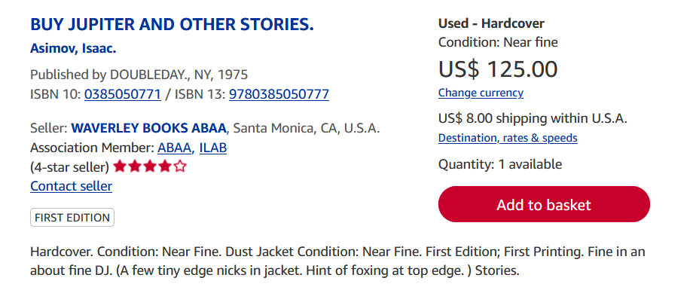
AbeBooks

